CUSTOM BOOTCAMP

**Azure ML Studio**

**Explore Azure Machine Learning Workspace Resources and Assets**

**Introducing Azure ML**

* Azure machine Learning provides a platform for data scientists to train, deploy, and manage their machine learning models on the Microsoft Azure Platform.
* It also provides a comprehensive set of resources and assets to train and deploy effective machine learning models.

**Give access to Azure ML Workspace**

Access is granted using role-based access control. There are three general built-in roles that you can use across resources and resource groups to assign permissions to other users:

* Owners: Gets full access to all resources and can grant access to others using success control.
* Contributor
* Reader

**Identify ML Resources**

* Workspace
* Compute Resources: Four types of compute instances.
* Datastores: All data is stored in datastores, which are references to Azure data services. When connected to the workspace, two datastores will be added to your workspace: workspacefilestore and workspaceblobstore.

**Identify Azure ML Assets**

* Models: You can train ML models with various frameworks, like Scikit-learn or PyTorch. A common way is to store such models is to package the model as a Python pickle file (.pkl extension)
* Environments: Specify software packages, environment variables, and software settings to run scripts. An environment is stored as an image in the Azure Container Registry created with the workspace when it’s used for the first time.
* Data: You can use data assets to easily access data every time, without having to provide authentication every time you want to access it. When you create a data asset in the workspace, you’ll specify the path to point to the file or folder., and the name and version.
* Components: Make it easier to share code with component in a workspace.

**Different Types of Job**

* Command: Execute a single script.
* Sweep: Perform hyperparameter tuning when executing a single script
* Pipeline

**Creating ML Workspace**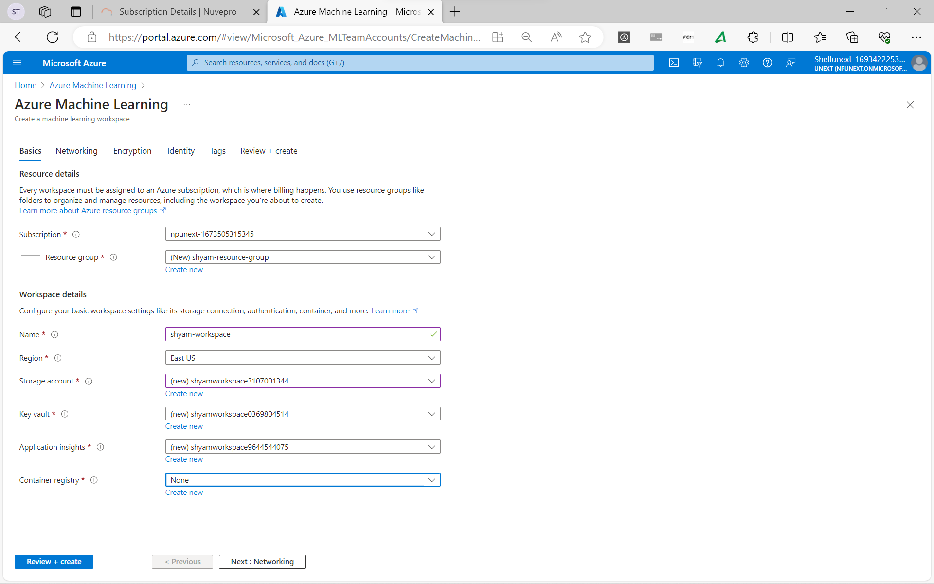 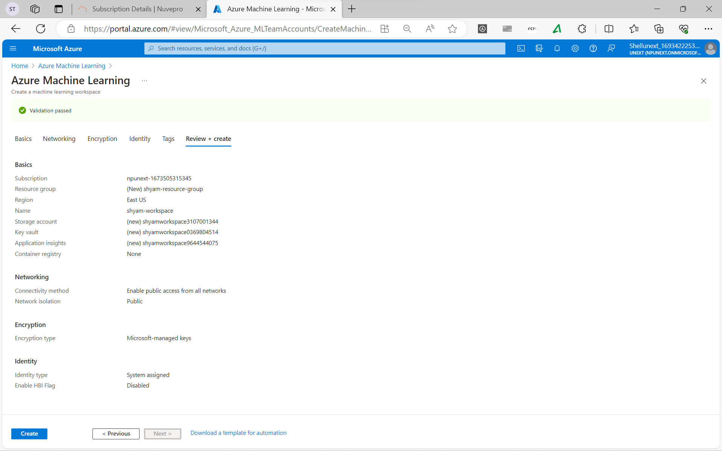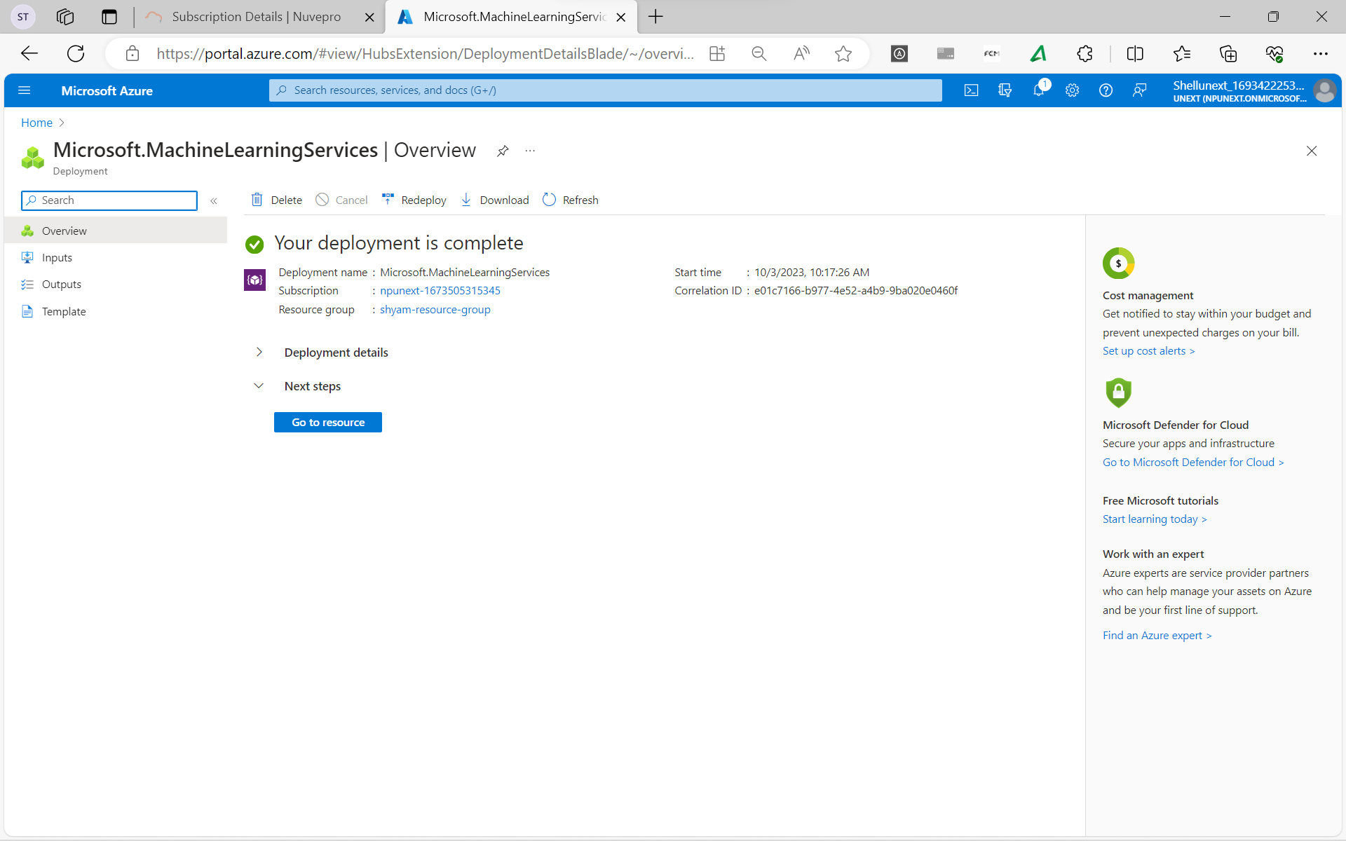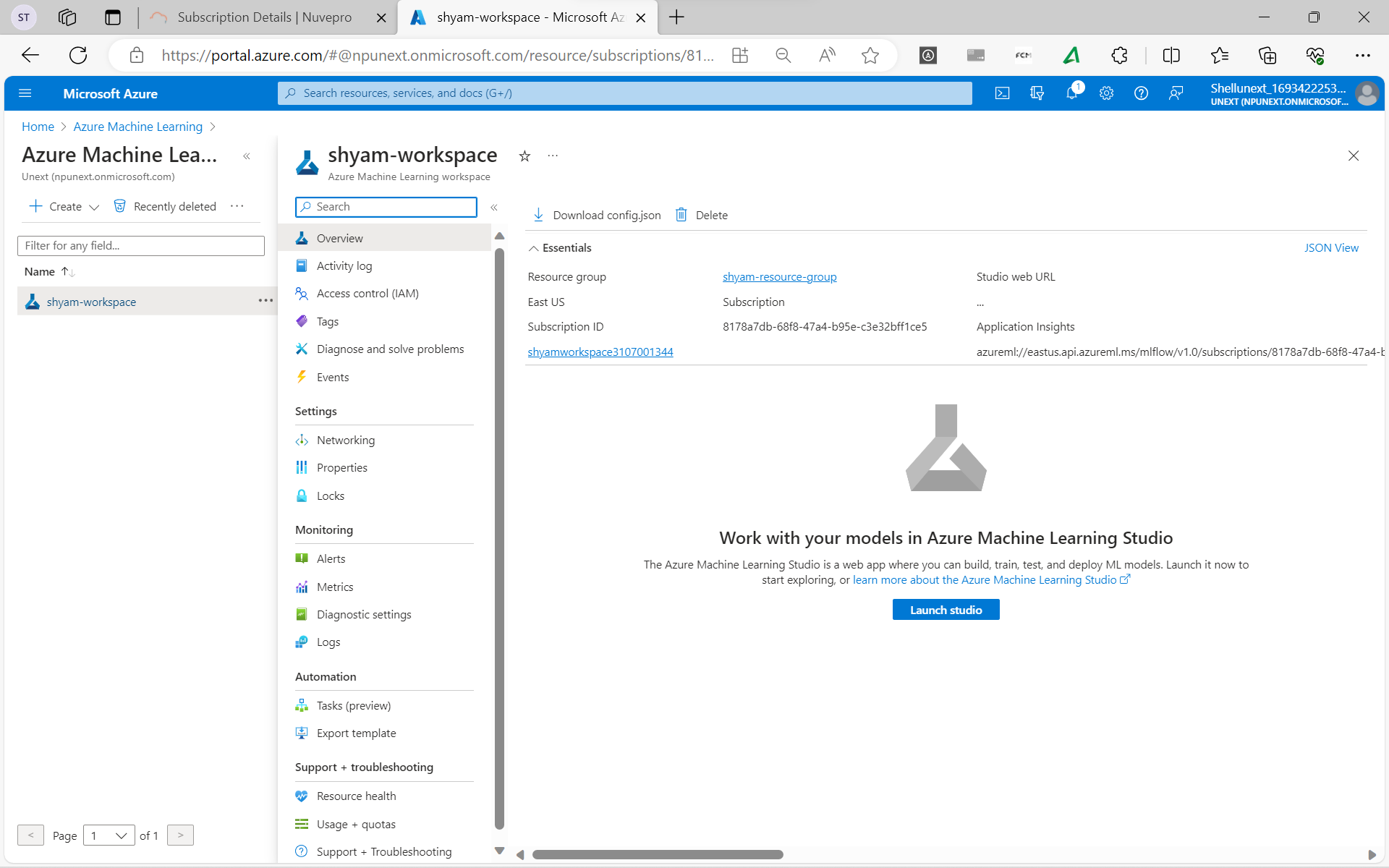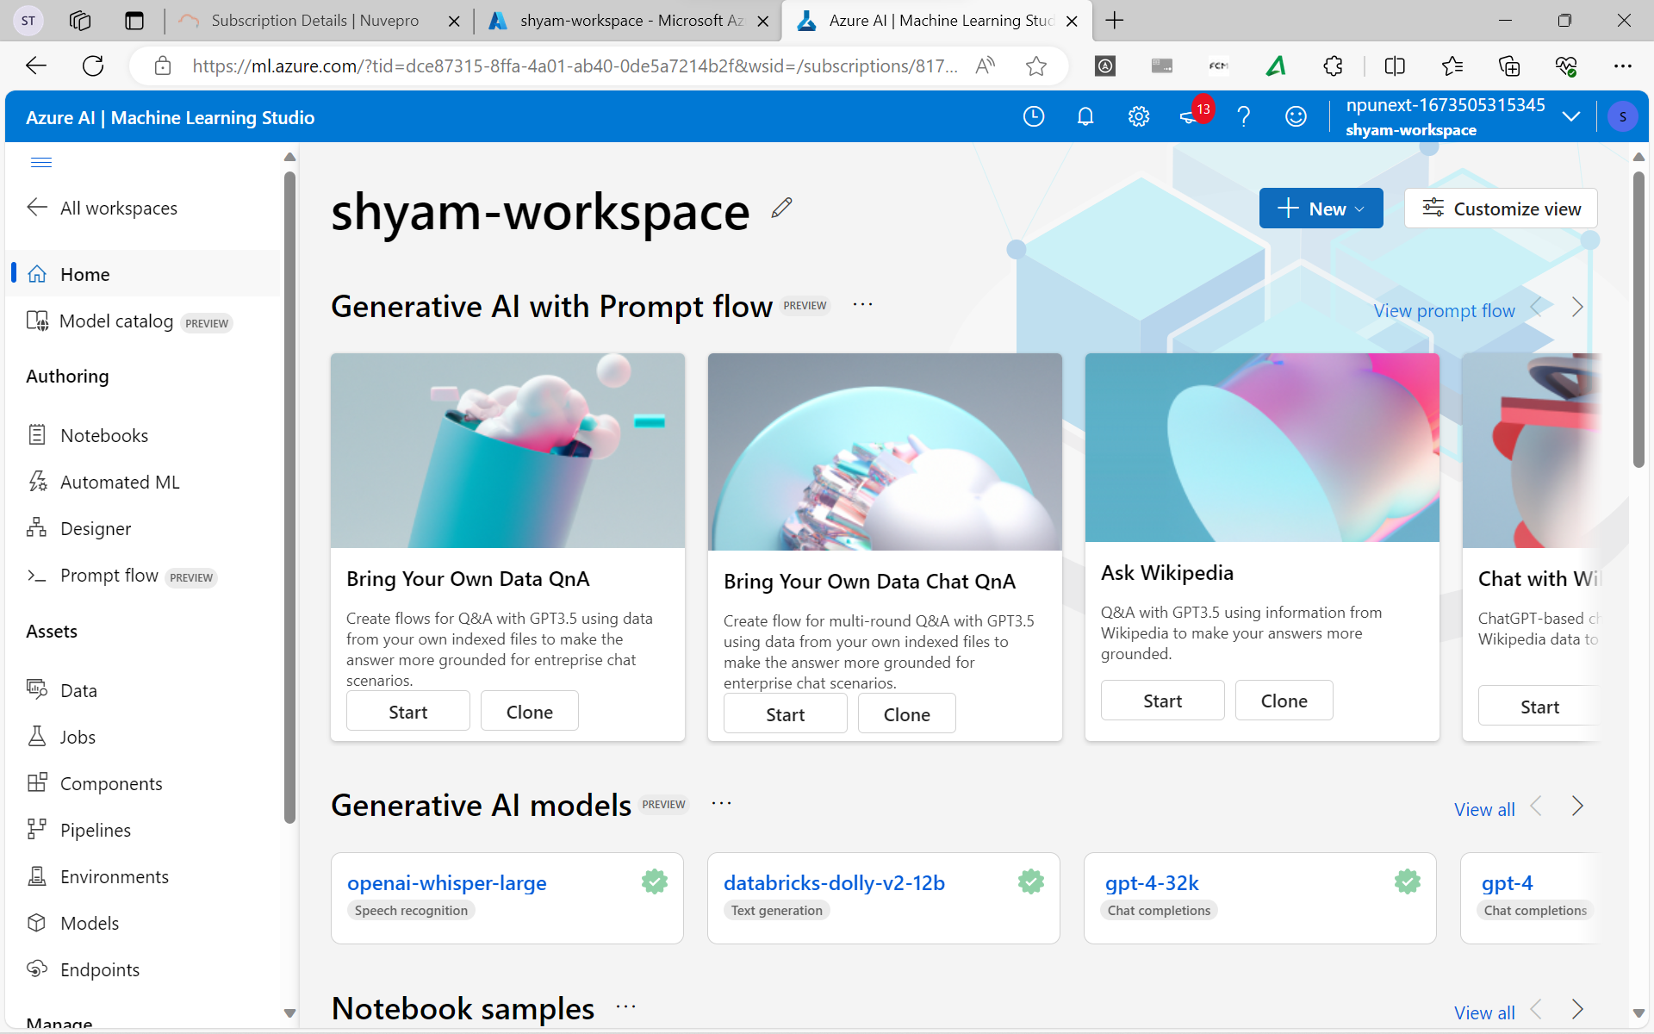

**Creating Compute Cluster**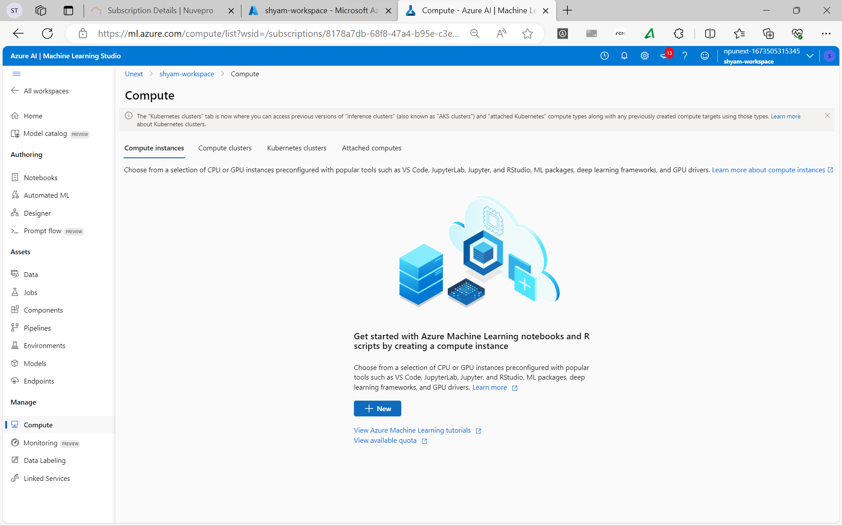

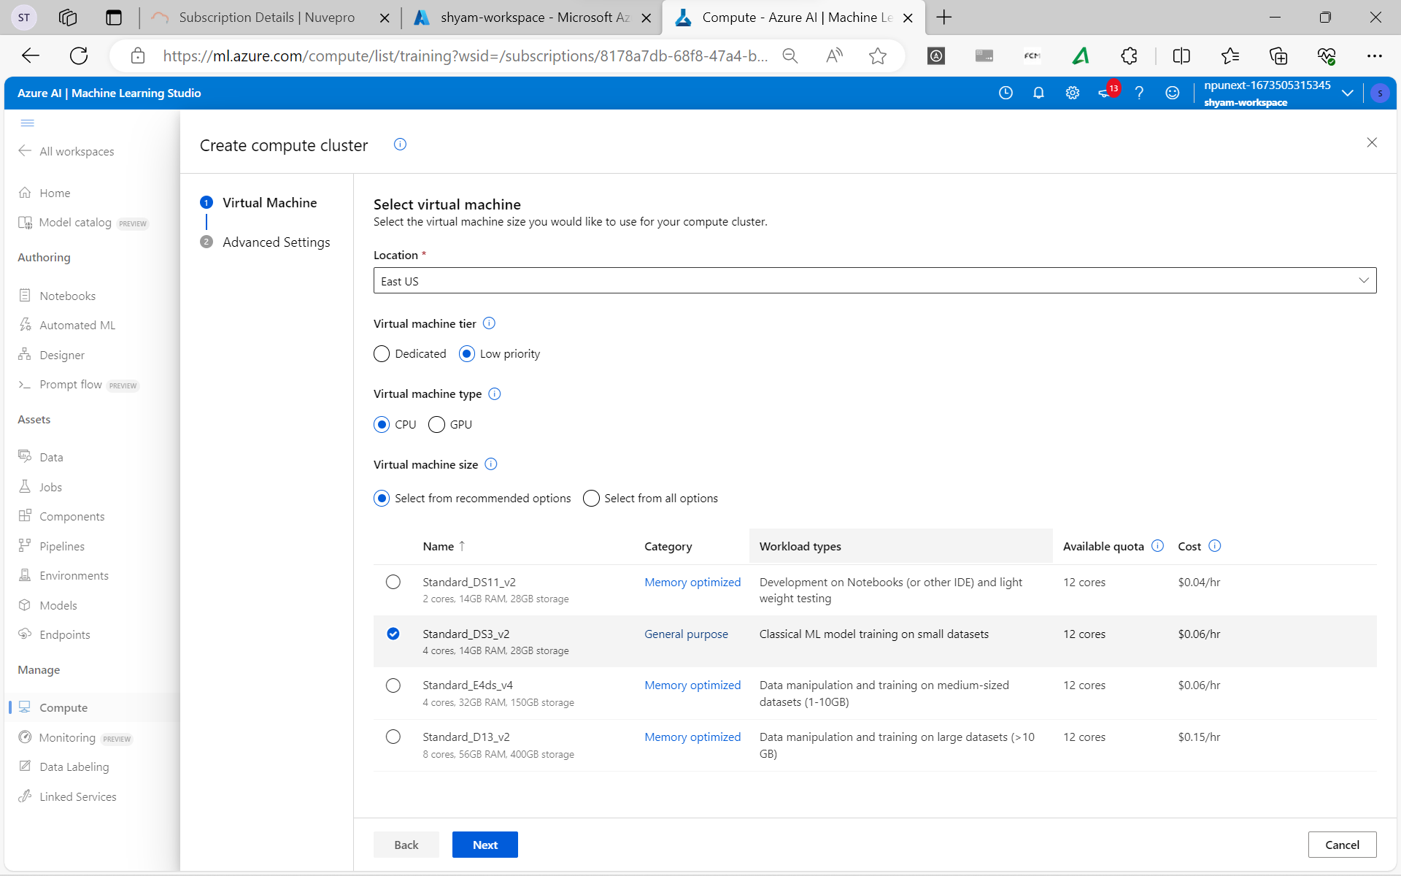 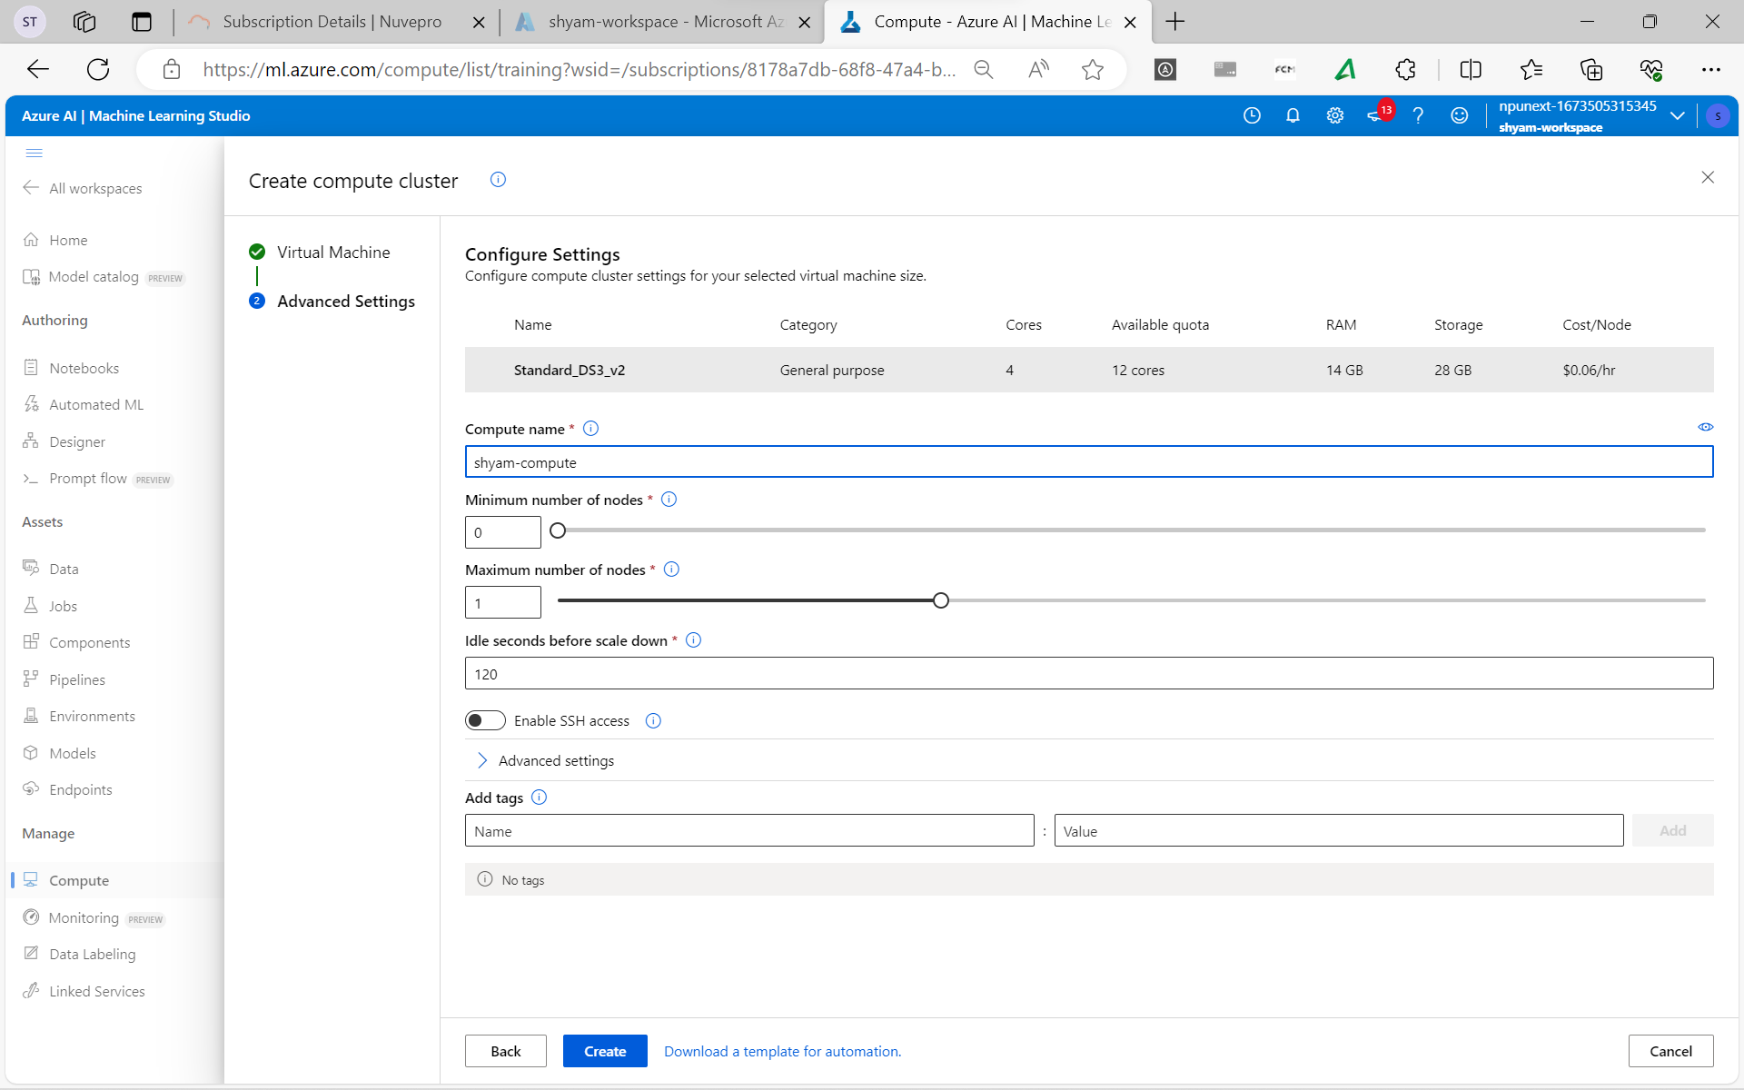 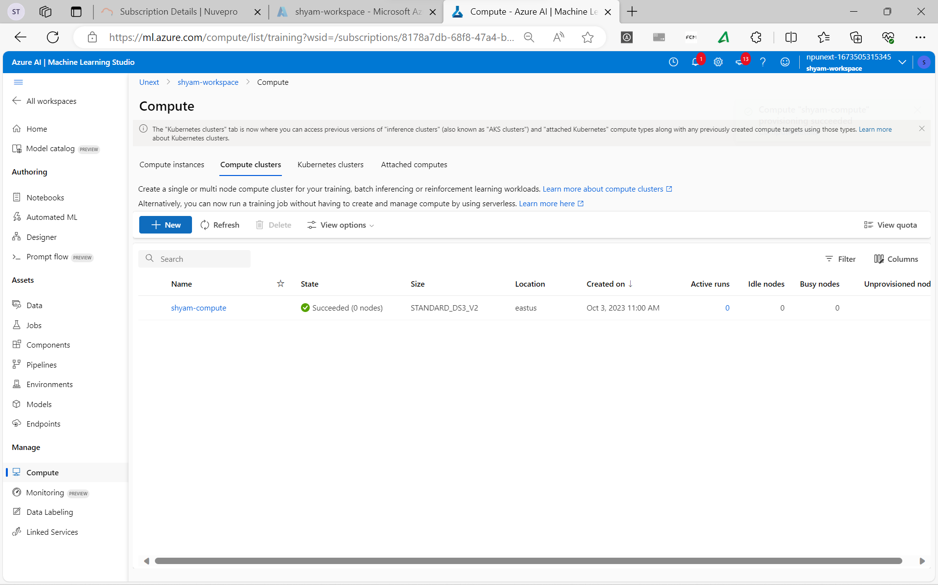

**Create Data Assets** 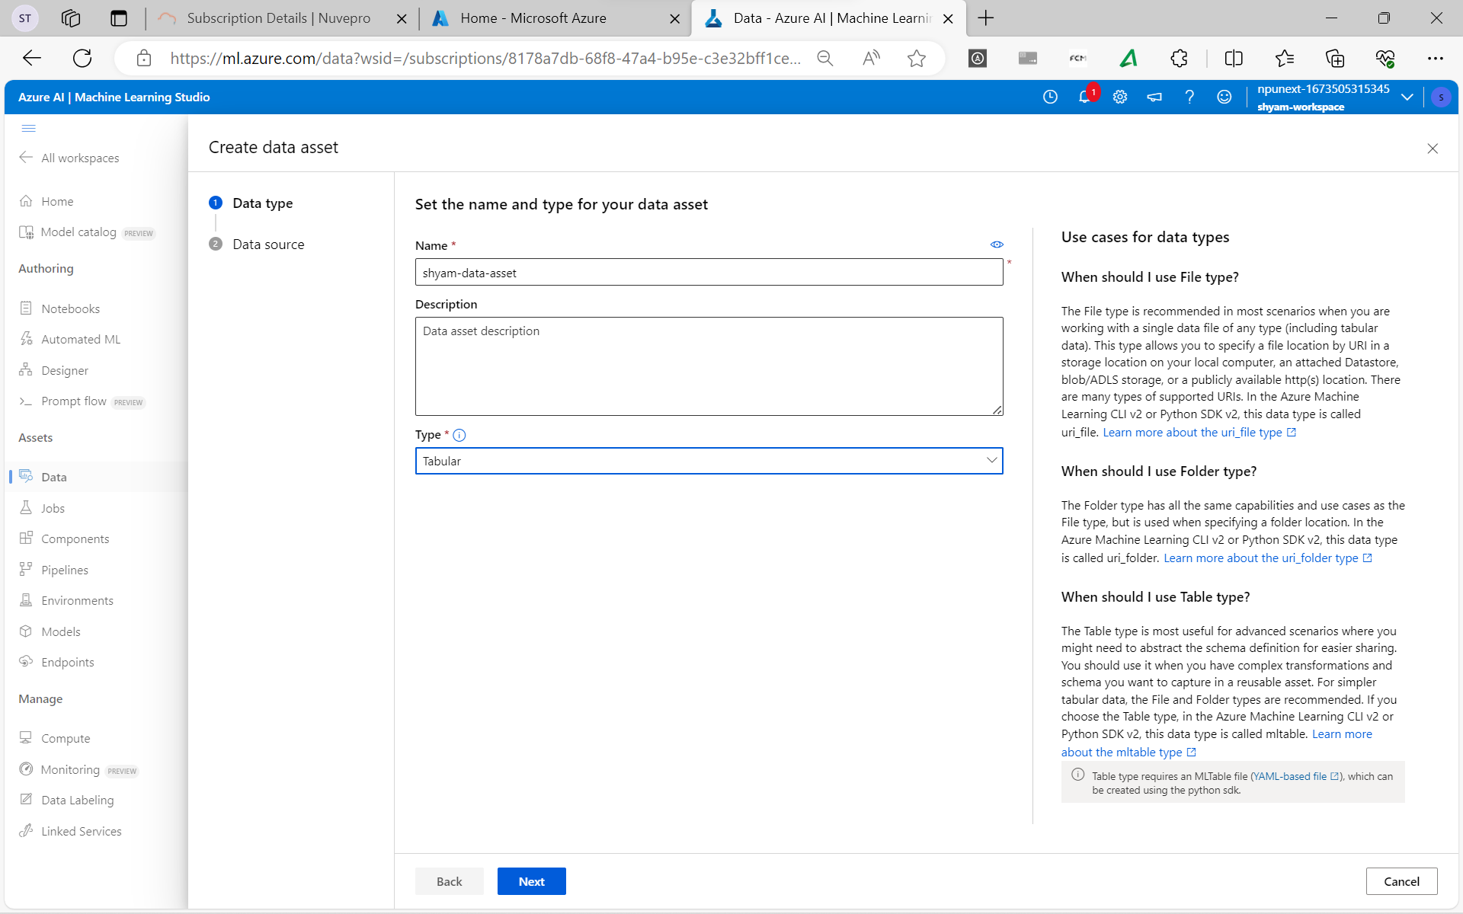 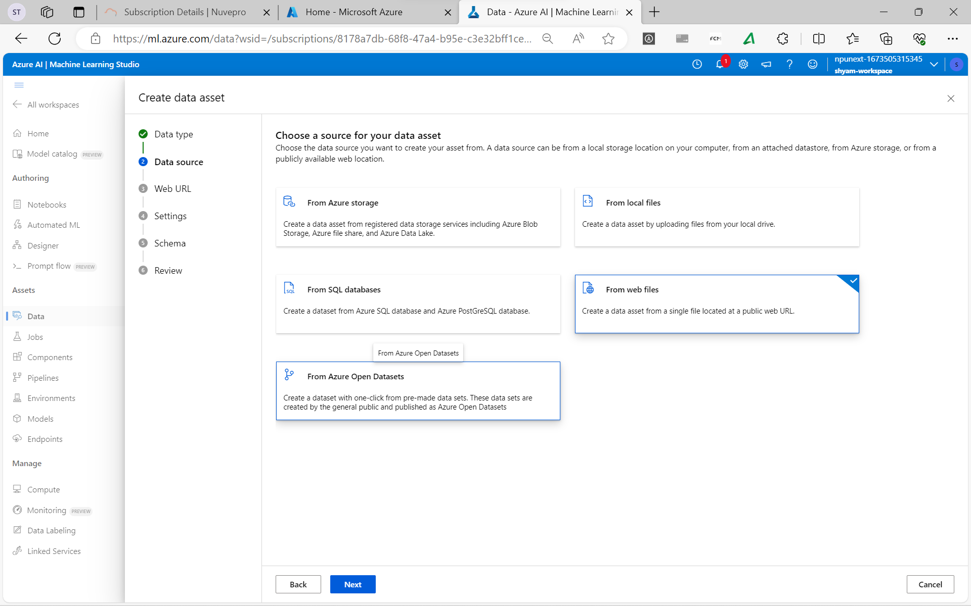 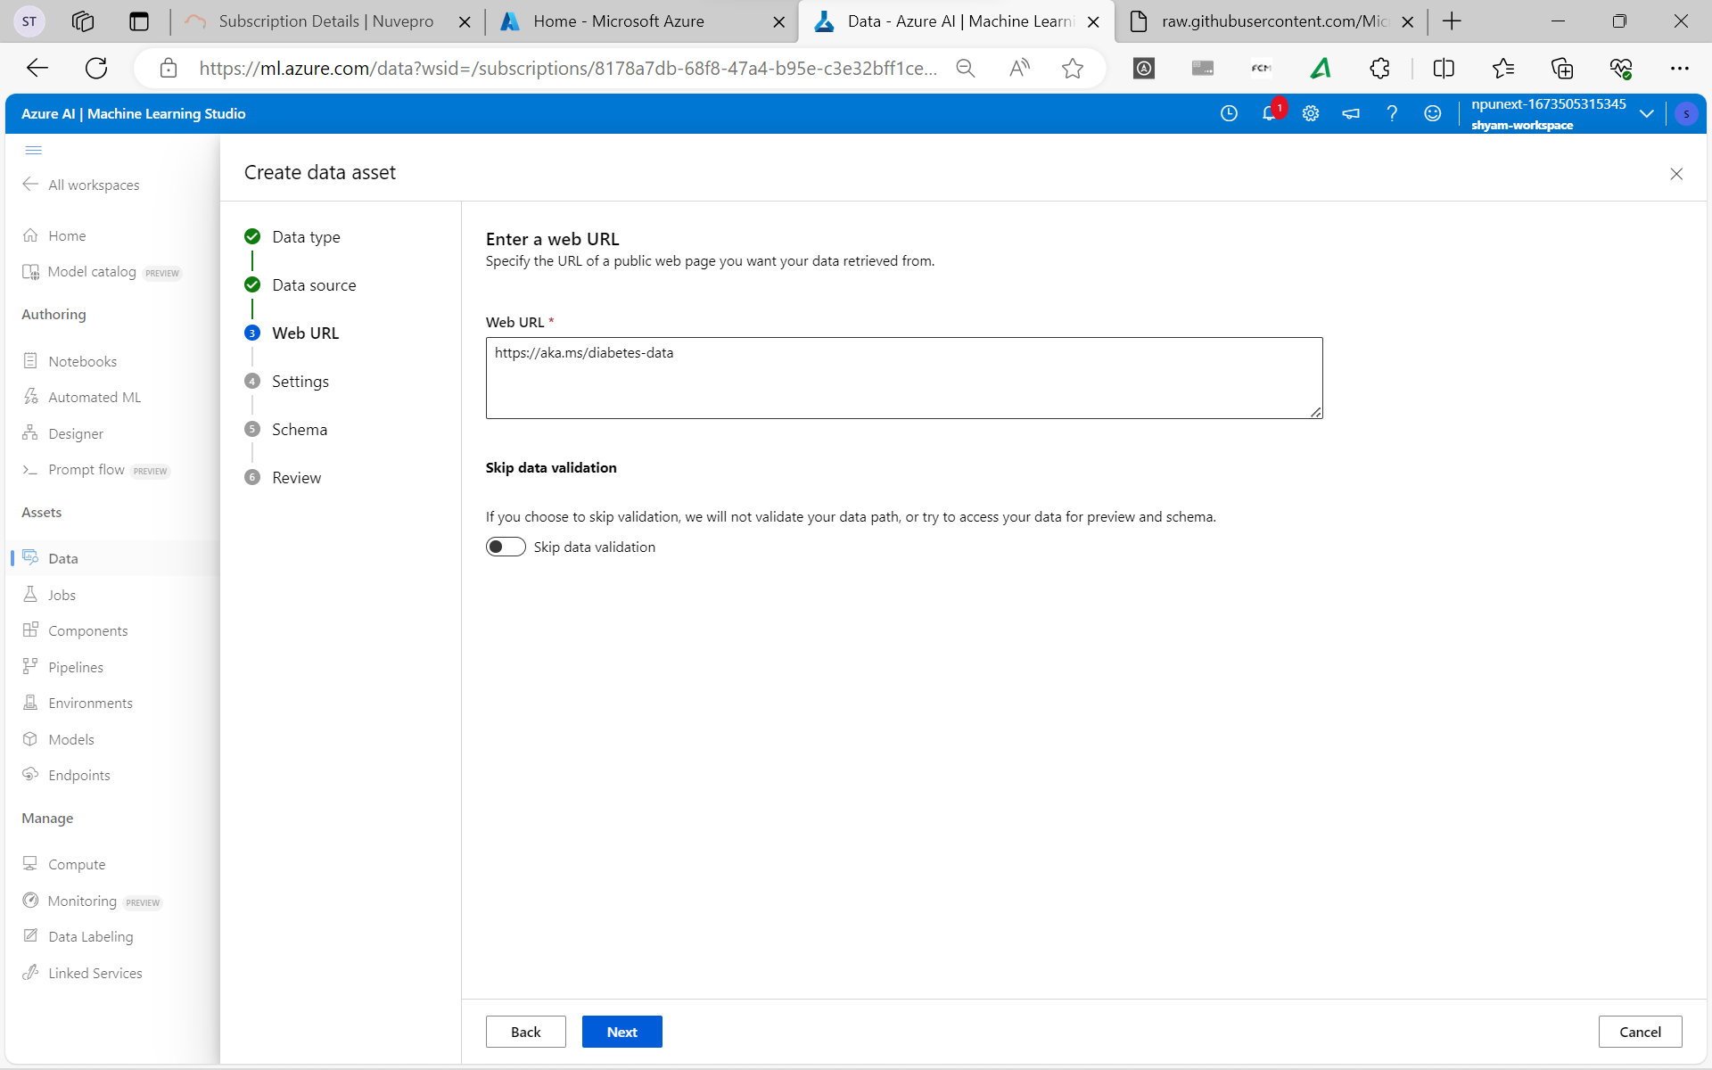 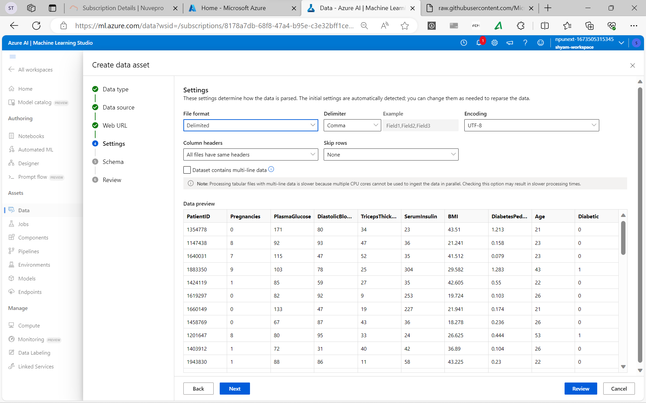 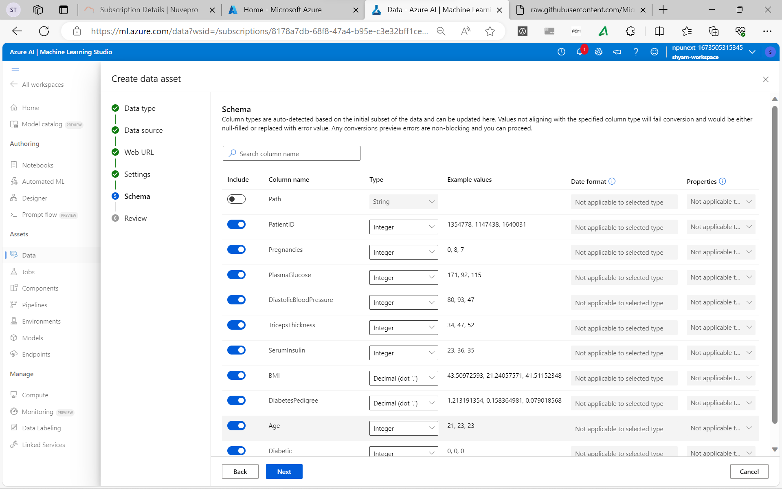 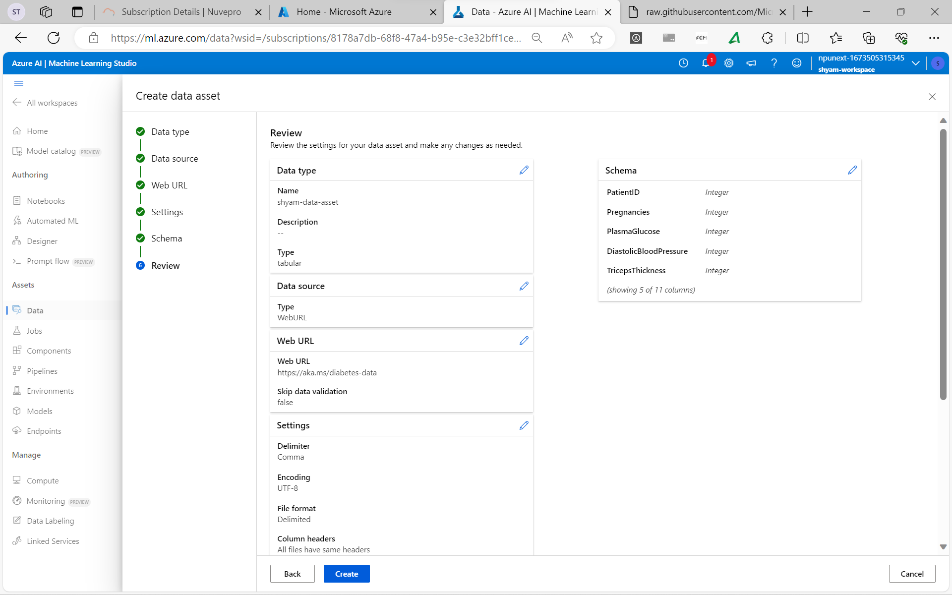 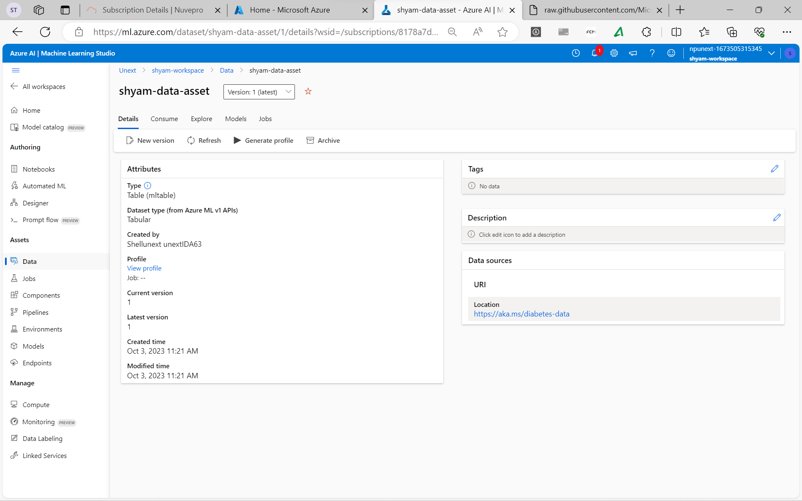

**Explore ML Studio**

**Explore the CLI**

The Azure CLI is commonly used by administrators and engineers to automate tasks in Azure.

**Make Data Available in Azure ML**

**Understand URIs**

A URI references the location of your data. There are three commmon protocols when working with data in the context of Azure ML:

* https
* http
* …….

**Create a Component**

* Metadata
* Interface
* Command, Code and Environment

**Create a Pipeline**

In Azure ML, a pipeline is a workfow of machine learning tasks in which each task is defined as a component.

**Azure CLI**